On Alfresco ECM Platform
Citeck EcoS Case Management mapping to CMMN 1.1
Author: Simonov Pavel
pavel.simonov@citeck.ru
2016
Table of contents

Charts of entities 3
Сiteck EcoS 3
Case Management Model and Notation 4
Reworking 5

Charts of entities

Сiteck EcoS
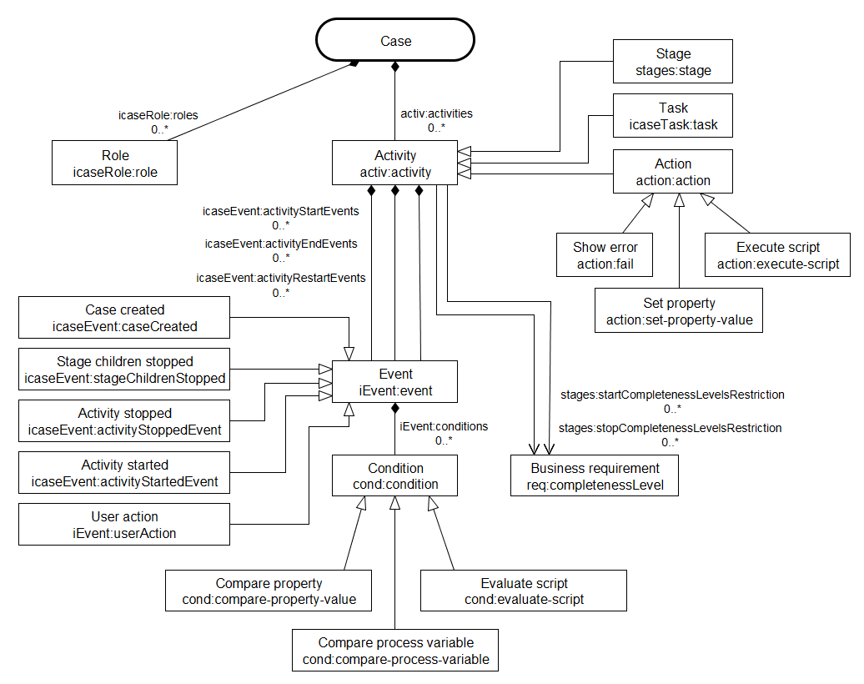
Figure1 – Entities’ chart of case management in CiteckEcoS
- Case  - Role  - Activity  - Stage  - Task  - Action  - Show error  - Set property  - Execute script  - Business requirement | - Event  - Case created  - Stage children stopped  - Activity stopped  - Activity started  - User action  - Condition  - Compare property  - Evaluate script  - Compare process variable

Case Management Model and Notation

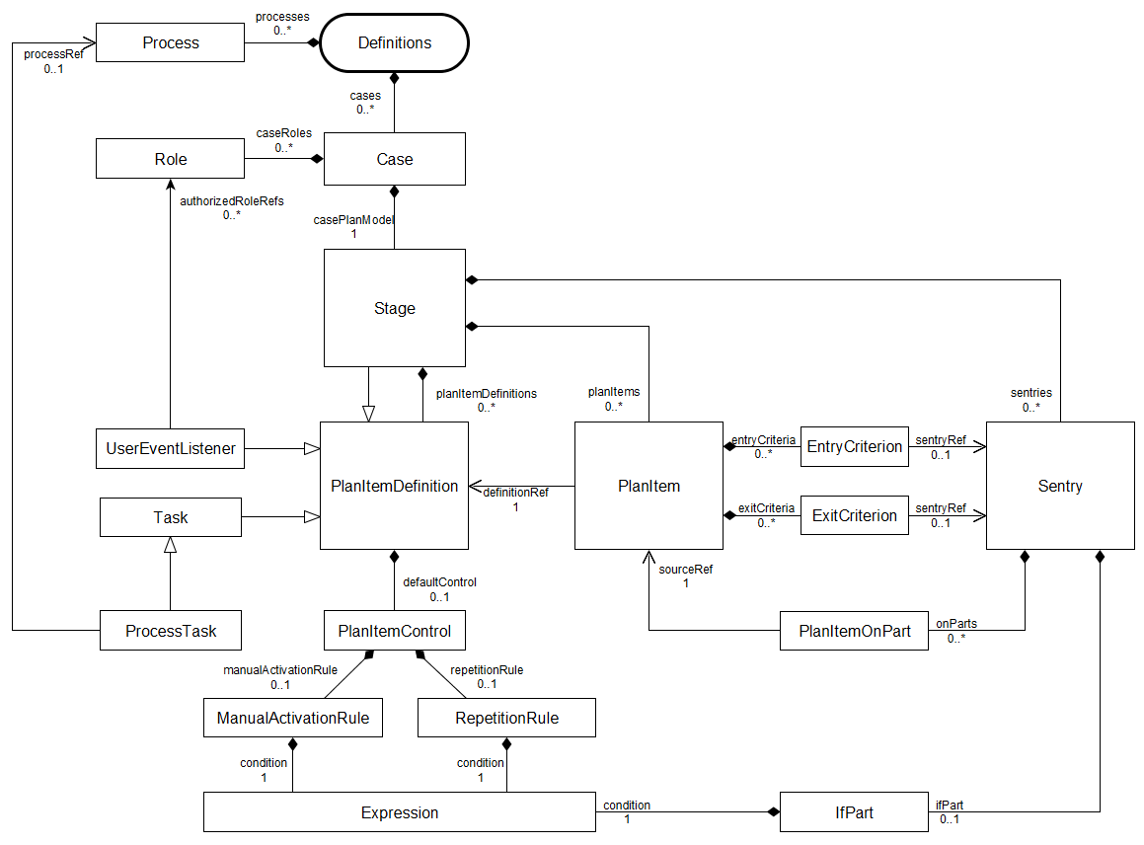
Figure 2 – Entities’ chart of case management in CMMN 1.1*
- Definitions  - Case  - Role  - PlanItemDefinition  - Stage  - Task  - ProcessTask  - UserEventListener  - PlanItem  - Process | - Criterion  - EntryCriterion  - ExitCriterion  - Sentry  - PlanItemOnPart  - IfPart  - Expression  - PlanItemControl  - ManualActivationRule  - RepetitionRule

* illustrated only those entities which functional is implemented in CiteckEcoS

Reworking
- AuthorizedRoles
a) add the icaseRole:hasAuthorizedRoles aspect to the roles’ model (icaseRoleModel.xml) with one multiple association icaseRole:authorizedRoles;
b) add icaseRole:authorizedRoles field to the iEvent:userAction creation form;
c) Complement the CaseActionsProvider with a verification code of a current user presence in the authorizedRoles list (directly in one of roles or within one of group selected to the role). If there is a user, an action will be restored, if not, the action will be hidden.

- Flag ‘repeatable’in activity
a) add the activ:repeatable boolean property to the (icaseActivityModel.xml ->activ:activity) activities model;
b) add a new property to the activities creation forms (stage, task, action);
c) expand the “startActivity” method in CaseActivityServiceImpl by adding there logic for activities restart:
When the startActivity method was called: If an activity is completed, one checks a “repeatable” flag and if it is true, resetActivity method is called and then code from startActivity should be executed
d) complete an invariant for relevance for icaseEvent:activityRestartEvents. This field should be hidden if it is empty and shown only if it is filled in;
e) Comment above the icaseEvent:hasActivityRestartEvents aspect on the fact it is out of date and there is repeatable flag instead of it;
f) Create a script to transfer all events from an icaseEvent:activityRestartEvents association to icaseEvent:activityStartEvents and a repeatable flag installation if there were such associations.

- Stage stages:autoComplete
a) add the stages:autoComplete flag to the (stagesModel.xml ->stages:stage) stages model;
b) add a flag to creation/editing forms;
c) remove the icaseEvent:stageChildrenStopped creation form;
d) In the CaseActivityEventTrigger a method tryToFireStageChildrenStoppedEvents:
- Change a method name to tryToCompleteStages;
- Replace eventService.fireEvent to caseActivityService.stopActivity;
- Add verification for a presence of the autoComplete flag (only if it is true, call caseActivityService.stopActivity)

